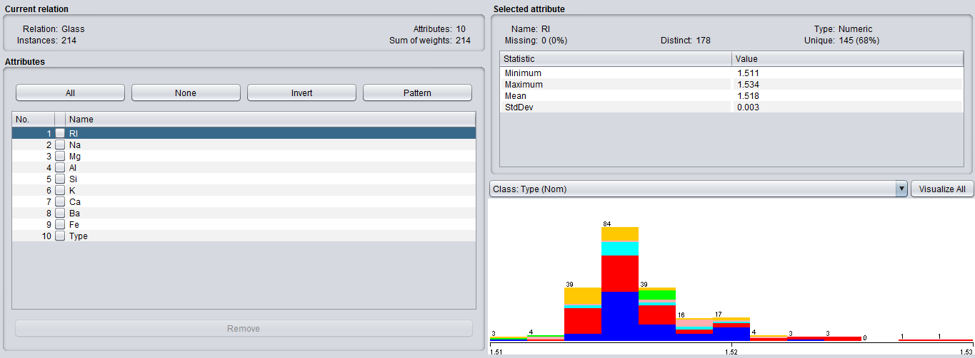

**GLASS DATASET**

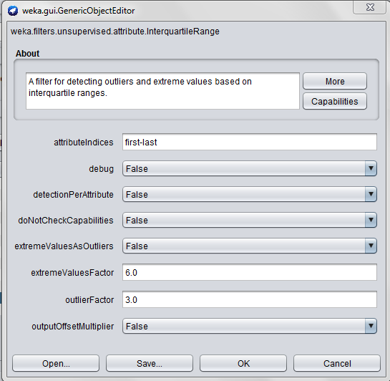

**INTERQUARTILE RANGE DESCRIPTION**

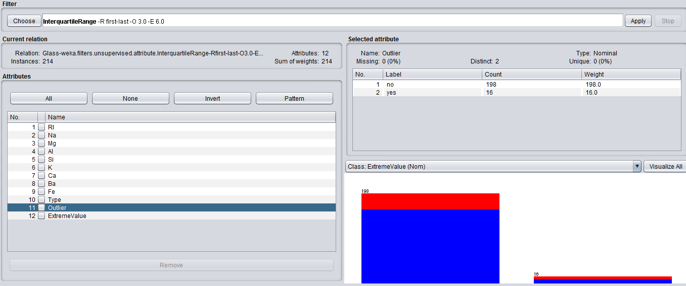

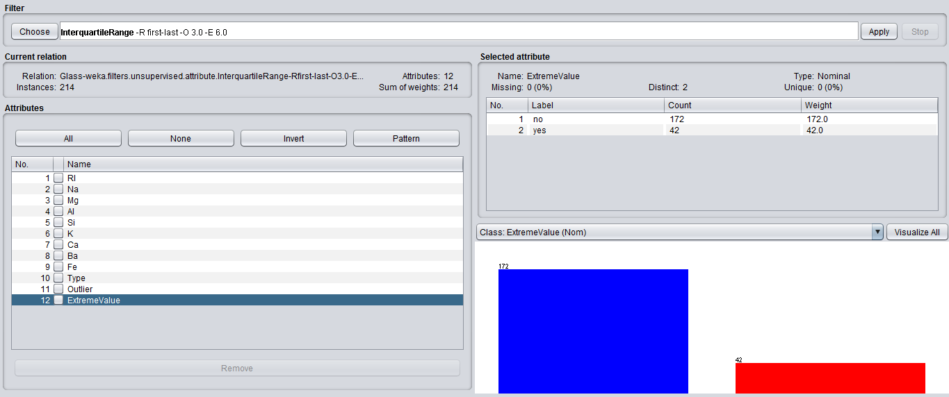**OUTPUT: OUTLIER**

**OUTPUT: EXTREME VALUE**

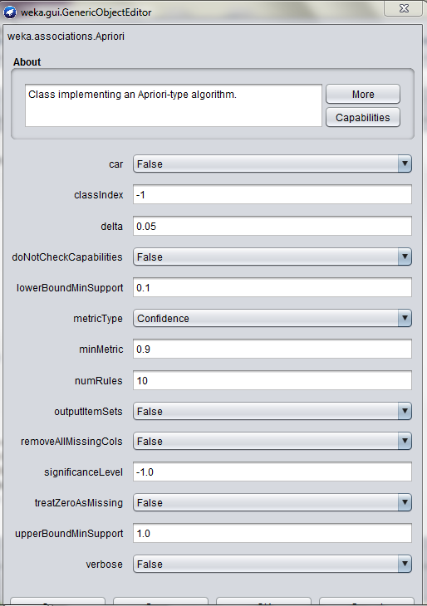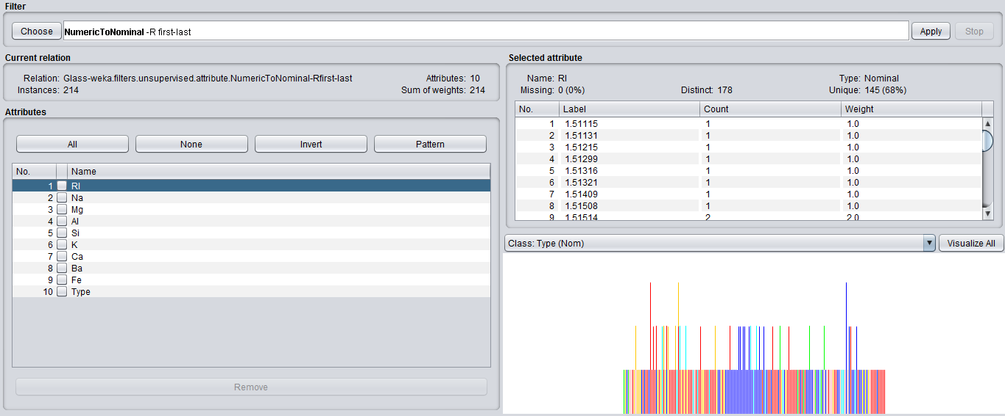**CONVERTING NUMERIC VALUES TO NOMINAL FOR APPLYING APRIORI**

**APRIORI DESCRIPTION**

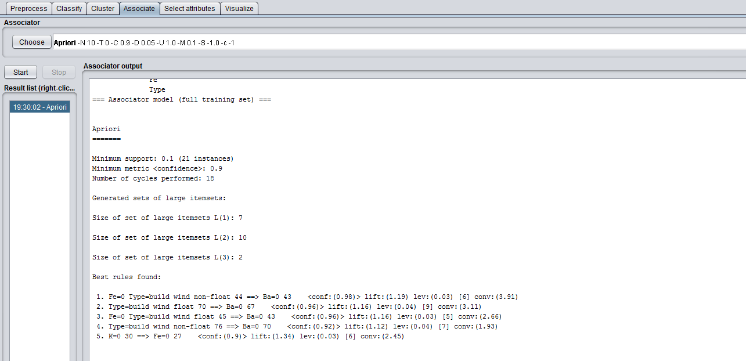**OUTPUT: APRIORI**

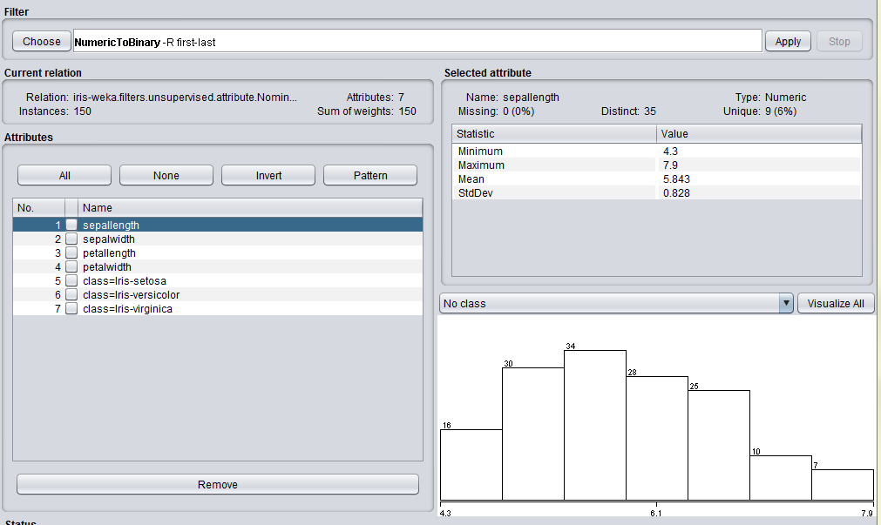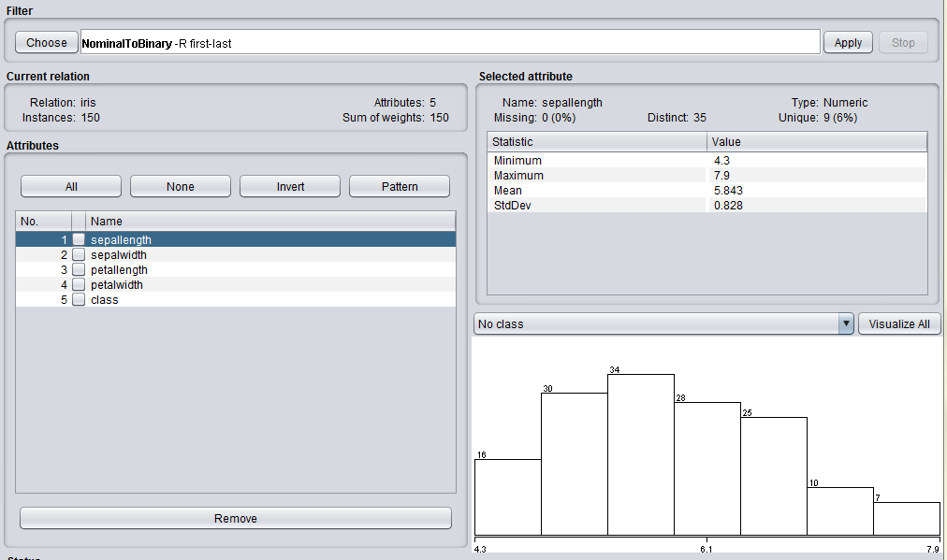**CONVERTING NOMINAL ATTRIBUTES TO BINARY FOR APPLYING FP GROWTH**

**CONVERTING NUMERIC TO BINARY FOR APPLYING FP GROWTH**

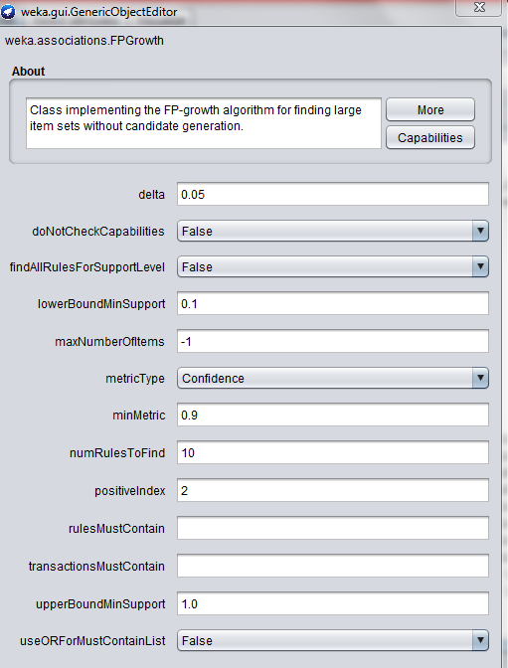

**DESCRIPTION OF FP GROWTH**

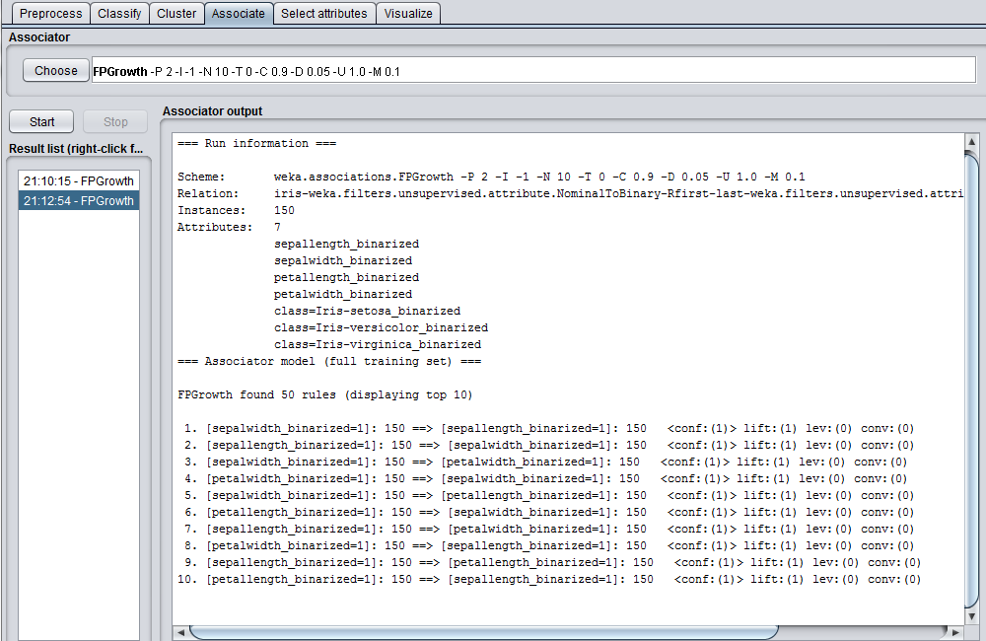

**OUTPUT: FP GROWTH**

**install.packages("arules")**

**install.packages("arulesViz")**

**library(arules)**

**library(arulesViz)**

**library(datasets)**

**data(Groceries)**

**itemFrequencyPlot(Groceries,topN=20,type="absolute")**

**rules <- apriori(Groceries, parameter = list(supp = 0.001, conf = 0.8))**

**options(digits=2)**

**inspect(rules[1:5])**

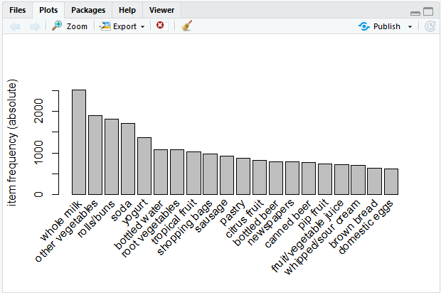

**rules <- apriori(Groceries, parameter = list(supp = 0.001, conf = 0.8))**

**options(digits=2)**

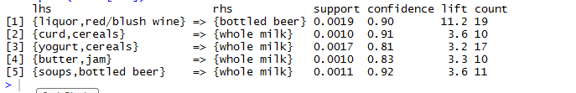**inspect(rules[1:5])**

**rules <- apriori(Groceries, parameter = list(supp = 0.001, conf = 0.8,maxlen=3))**

**options(digits=3)**

**rules<-sort(rules, by="confidence", decreasing=TRUE)**

**inspect(rules[1:5])**

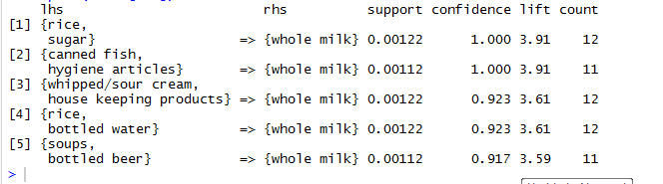

**rules<-apriori(data=Groceries, parameter=list(supp=0.001,conf = 0.08),**

**appearance = list(default="lhs",rhs="whole milk"),**

**control = list(verbose=F))**

**rules<-sort(rules, decreasing=TRUE,by="confidence")**

**inspect(rules[1:5])**

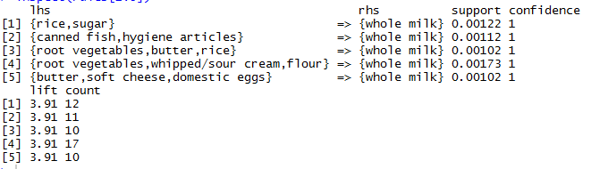

**rules<-apriori(data=Groceries, parameter=list(supp=0.0015,conf = 0.9),**

**appearance = list(default="lhs",rhs="whole milk"),**

**control = list(verbose=F))**

**rules<-sort(rules, by="confidence", decreasing=TRUE)**

**plot(rules,method="graph",interactive=TRUE,shading=NA)**

